Tanana Valley Watershed Association
2020 Annual Report of Adopt-a-Stream Program Activities for the
Fairbanks Stormwater Advisory Committee

Program Description: How it Works
The Fairbanks Stormwater Advisory Committee (FSWAC) and the Tanana Valley Watershed Association (TVWA) continue the Memorandum of Agreement to implement Adopt-a-Stream (AAS) programs within Fairbanks and North Pole. TVWA administers the AAS programs with the support of FSWAC. FSWAC provides program support through annual funding and additional in-kind assistance to TVWA, as well as hosting an annual Stream Cleanup Day and other events. TVWA implements and schedules program activities and maintains the participant list of adoptees and their designated stream sections. TVWA also submits an annual AAS report to FSWAC outlining tasks and community outreach accomplishments during the year.
The AAS programs are community-based programs with a variety of volunteer activities. The primary activities encompass water-quality monitoring and stream restoration and maintenance that provide residents and other stakeholders with the opportunity to participate as proactive watershed stewards. These watershed stewards also partake in litter pick-up, invasive species identification, and management of flow restrictions. Community stewards and volunteers hold a sense of ownership and role in local water quality issues. As a result, FSWAC and TVWA raise community education and awareness through the implementation of these programs while improving local water quality and develop a strong volunteer base.
The annual reporting includes records of program meetings held, number of community members participating in the programs, description of adopted stream sections, and a summary of cleanup efforts performed by adoptees and other volunteers. Measurable goals of the AAS programs are to increase the number/length of stream sections adopted each year and to continue to expand cleanup efforts within the watershed. Highlights of the year’s successes and achievements are included in the report.
The Alaska Department of Environmental Conservation (AK DEC) in accordance with Alaska Pollutant Discharge Elimination System (APDES) Permit No. AKS-053406 requires implementation of the AAS programs. The City of Fairbanks, City of North Pole, Alaska Department of Transportation & Public Facilities, and the University of Alaska Fairbanks comprise the co-permitted agencies who are responsible for permit compliance. AK DEC then submits the AAS data to the EPA’s Storage and Retrieval Data Warehouse (STORET), where the information is joined and preserved with National Water Information. All the data is accessible to agencies and the general public for exploring or for analytical details of each sample taken during the 2020 season.
2020 Community Outreach Accomplishments, Highlights & Resources
2020 Community Events: TVWA was able to still hold many of our community events this year through social distancing measures. We sought creative, visible solutions to engage community learning and care for local water bodies in addition to the traditional citizen-scientist framework. Several public events and educational sessions took place to address large threats to healthy water bodies, such as storm water issues, an uninformed public, and trends of disconnect between the youth and nature. Overall success of these projects enabled stronger community connection with the natural world and greater education publications, as with the Chena River.
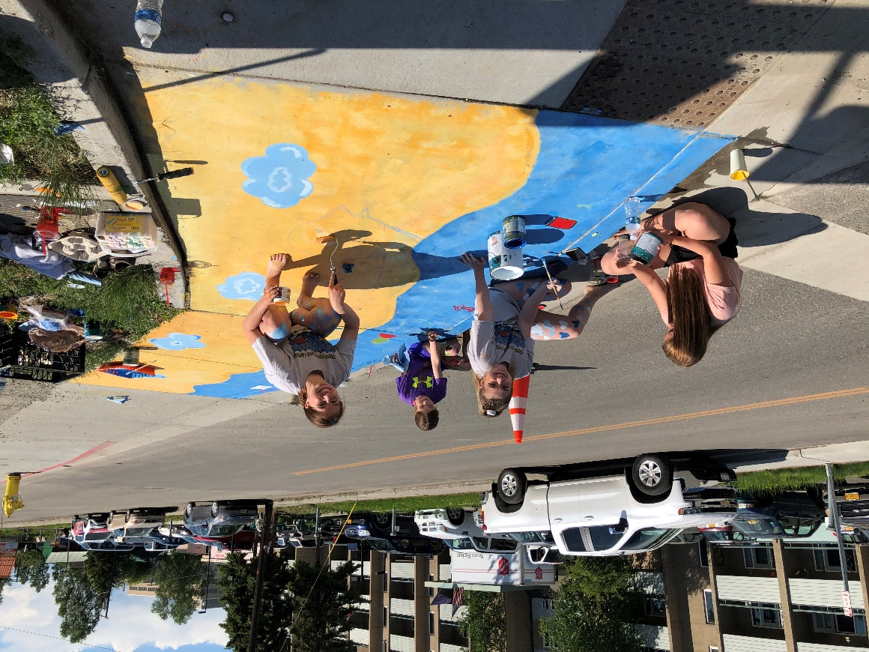
Volunteers painting Joanna Mata Bauman’s submission: “Ducks in a row…or not”. Taken by Arleigh Hitchcock for TVWA June 6, 2020
- Storm Drain Art Contest: Since 2014, TVWA has invited local artists to submit design proposals for storm drain art in downtown Fairbanks. The purpose of this project is to raise public awareness that ALL storm drains flow directly into the Chena River and to provide an opportunity for artists to create public works of art in the downtown and surrounding Fairbanks area. The past art was displayed for one year prior to the construction on Cushman Street (2014), Noble Street (2015), Cowles Street (2016), Gilliam Way (2017), Barnette Street (2018) and 5th Avenue (2019). This year, artists painted the storm drains on 3rd Avenue.

During the months of April and May - TVWA asks local artists to submit their art proposals to TVWA. The artist is asked to consider the following design ideas for their art entries. When designing the artwork, artists were encouraged to think of the following three themes:

1. Storm Water Pollution (litter, vehicle fluids, pet waste, soapy water, etc.)
2. Fish, Wildlife, Habitat (moose, beavers, ducks, salmon, grayling, willows, etc.)
3. Quality of Life (clean water for recreation, drinking, natural beauty, etc.)

TVWA created/sent out eblasts, Facebook posts, and updated their website to announce the Storm Drain Art contest. The contest originally ran from April 1st-30th and then was extended until May 15th, in that time 15 artists submitted 18 designs. On May 20th, TVWA sent out an email to TVWA Board Members and the Fairbanks Stormwater Action Committee requesting their votes on the submitted artwork. By May 25th, TVWA received 6 completed voting slips by email. TVWA contacted the winning artists and coordinated with the COF to organize painting day.

Type of Announcement | Date Sent | #emails | #Reached | #clicks/likes/loves
Constant Contact Eblast | 2/3/2020 | 40 | 87 | 14
Constant Contact Eblast | 4/1/2020 | 363 | 55 | 10
Constant Contact Eblast | 4/29/2020 | 364 | 62 | 4
Facebook Post | 2/3/2020 |  | 220 | 51
Facebook Post | 3/1/2020 |  | 208 | 24
Facebook Post | 3/25/2020 |  | 174 | 61
Facebook Post | 4/1/2020 |  | 107 | 44
Facebook Post | 4/22/2020 |  | 1,917 | 107
Facebook Post | 4/23/2020 |  | 57 | 9
Facebook Post | 4/29/2020 |  | 5,659 | 175
Facebook Post | 5/12/2020 |  | 2,504 | 69
Constant Contact Eblast | 5/12/2020 | 612 | 105 | 11
Constant Contact Eblast | 5/13/2020 | 576 | 91 | 4
Facebook Post | 5/14/2020 |  | 682 | 20
Facebook Post | 5/15/2020 |  | 55 | 1
Table 1: Announcement type, date of announcement, and how many people were directly reached for the 2020 Storm Dain Art Contest.

The painting was done on June 6th, 2020. A total of 11 designs were painted. The City of Fairbanks provided signs for traffic revision and cones/high visibility vests for artist’s safety. The artists are asked to paint between the hours of 9 am and 5 pm. Staff from TVWA and the City of Fairbanks were on site to help with any questions they might have. TVWA supplied light snacks, masks, hand sanitizer and refreshments to the artists on the day of painting. Staff from TVWA then sealed the art on the storm drains with a high durability sealer so that everyone could enjoy the colorful pieces for the rest of the summer.

TVWA posted pictures and updates to their website and Facebook page.

Pictures of this and prior year’s events are posted on our website and in a display case at the Noel Wien Public Library: www.tvwatershed.org/storm-drain-art/.

“Out in the Community” Public Events: TVWA hosted AAS training and participated in the Stream Clean-Up Day. Unfortunately due to Covid, the Home Show, KTVF Kids Day Activity Fair, Alaska Agriculture Day, Outdoors Day, and the Midnight Sun Festival did not take place this year. We have found these events to be very successful at promoting the Adopt-a-Stream program and educating family and youth about water quality issues and watershed stewardship. Not being able to go to these events means that there was less in person promoting of our AAS program and we had to depend on social media instead.

- May 10th and 11th – AAS Training: Our AAS Training was held virtually this year via Zoom on May 15th and 16th from 12-1 pm at our office downtown. We had 7 attendees. TVWA provided volunteers with individual water quality monitoring training at TVWA. Training was approximately thirty minutes. Information at the training covered proper sampling techniques and how to use a Hanna® meter to measure pH, conductivity, temperature, and record useful observations. TVTWA Staff then coordinated giving volunteers their handout documents and water testing kits. Volunteers were also given information about invasive weed identification and were asked to report their presence along with the water quality monitoring data. Volunteers turned in their data by October 30th and data was entered in the EPA water quality collection spreadsheet and submitted to AK DEC.

During the months of May to September – AAS volunteers and a TVWA field tech sampled 16 areas along the Chena River and surrounding waterways.

AAS training ad posted: TVWA Facebook page and TVWA mailing list eblast.

- June 13th - Annual Stream Clean-Up Day: TVWA assisted with the 16th Annual Stream Clean-Up Day. We posted invites to the event on our Facebook page. We also assisted with volunteer management and logistics. In 2017, over 25 volunteers cleaned up 560 pounds of trash and waste from Noyes Slough and the Chena River. At the 2018 event, over 30 volunteers cleaned 900 pounds of trash and waste. At the 2019 event, over 32 volunteers collected an estimate of 1,960 pounds of trash. This year over 50+ community volunteers collected over 400 pounds of trash. Despite COVID and with social distancing, we had more volunteers show up than any other year.

2020 Adopt-a-Stream Data
Locations: TVWA and volunteers sampled 22 locations from May through October. The sampling sites include Chena River (14), Tanana River (2), Chena Lakes (1), Tanana Lakes (2), Smith Lake (2), and Chena Slough (1). Water quality (temperature, pH, and conductivity) were tested during each sampling event using a Hanna HI 98129 pH/EC/TDS/Temperature meter. Meter calibration was done prior to and after the water testing each week using solution standards of pH 4, pH 10, and 1413µS.
Data: Graphs showing monthly trends by year were created for sites that were sampled for two or more years. These graphs are available as PDFs and can be found at the following link: http://www.tvwatershed.org/aas/
Map: An interactive Google Map was also created to showcase the AAS program locations. It shows a fish for locations that were sampled from 2013-2020. This map can be accessed via the following link: Fairbanks AAS sampling locations.

