Piledriver Slough Beaver Activity Survey Report 2014
Tanana Valley Watershed Association
February 4, 2015

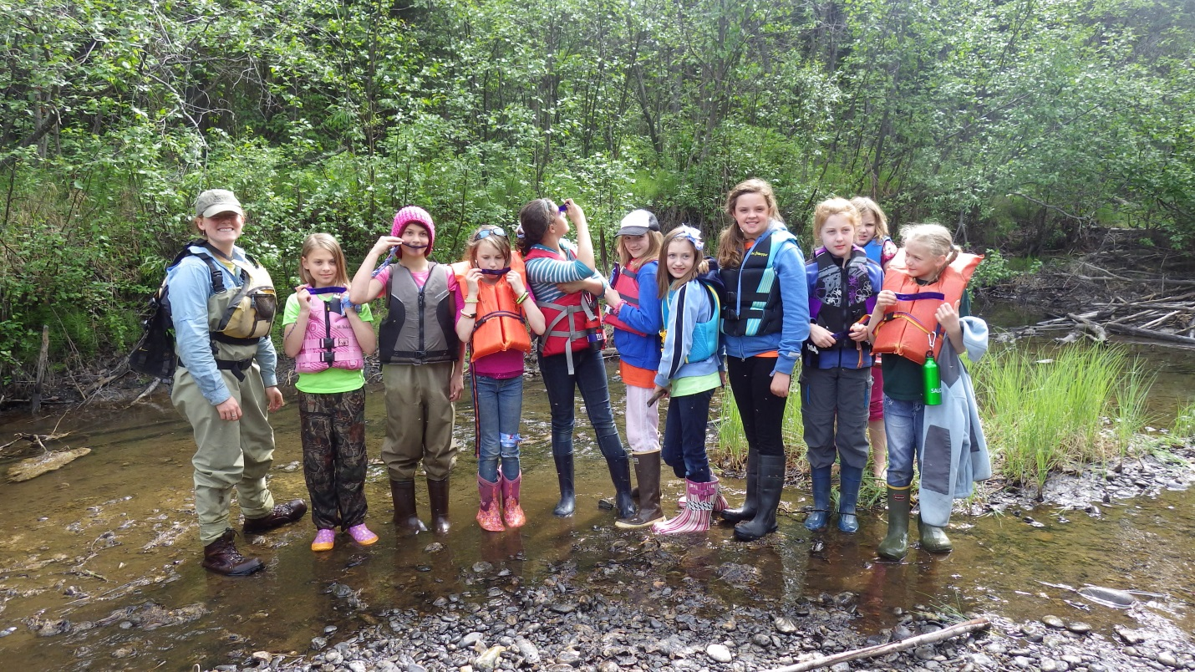

Introduction
This report discloses the findings of the 2014 study undertook by the Tanana Valley Watershed Association (TVWA) on Piledriver Slough and 23 mile slough. For this study, Piledriver Slough was dissected into upper and lower subdivisions for monitoring. Participant citizen student-scientist within the Salcha School District in collaboration and supervision of TVWA staff monitored the lower Piledriver Slough. TVWA staff members solely monitored the upper Piledriver Slough section and the 23 Mile Slough. Survey site results are discussed below.

Purpose
This ten-year study is within its third year pursuant to fulfillment of the Mitigation Measure 56 of the Service Transportation Board. The measure states, “prior to construction of Salcha Alternative Segment 1, ARRC shall develop appropriate mitigation in consultation with ADF&G to prevent blockage of Piledriver and 23 Mile Sloughs by beaver dams (as a result of flushing flows caused by ARRC-proposed channel plugs). Mitigation may include monitoring conducted by ARRC at a frequency agreed to by ADF&G.” The Piledriver Slough Mitigation Plan was created to assess impacts of the Northern Rail Extension Project-Phase 1.

Need
A levee was put into place to alleviate blockage to spring flow flushing from the Tanana River into the Piledriver Slough due to construction of the new rail extension. With the construction of the levee, concerns were raised about the potential alteration in flow-rate because of the lacking ability of natural flushing of debris or ice build-up by spring flows. Resulting concerns include ice and log jams and beaver dams impeding fish passage. This study was created to assess the risk that such obstructions pose to fish passage.
Objectives

The Alaska Department of Fish and Game (AKDFG) consults TVWA in action through a Memorandum of Agreement implementing fish monitoring within the Piledriver Slough located in the City of Salcha and the 23 Mile Slough. TVWA is charged to manage the Piledriver Slough Beaver Activity Survey program until to 2022, in which a final report will be submitted to AKDF&G and the Alaska Rail Road (AKRR). The report will compile results and conclusions drawn from outlined objectives and accomplishments achieved during the 10-year study.

Methodology

The ten-mile section of the Piledriver Slough was divided into two sections as sought as the best mechanism for managing monitoring based upon distance from the levee site to the Bailey Bridge. These sections were the Upper Piledriver and Lower Piledriver. Upper Piledriver surveying began from the levee site and ended at the Old Valdez Trail road crossing. This section was surveyed by TVWA staff with the assistance of citizen scientists from the Salcha Elementary. Lower Piledriver surveying began from the Old Valdez Trail road crossing ended at the Bailey Bridge, adjacent to Eielson Airforce Base. This section was surveyed by TVWA staff. Undivided, the 23 Mile Slough site was located and surveyed in its entirety off of Old Eielson Farm Road. All surveys took place late spring, summer, and late fall, which exact dates dependent on staff availability.

For the study of Upper Piledriver, TVWA trained volunteers and students to whom acted as citizen scientist through a presentation and science curriculum on water safety, fish and plant ID, fish handling, water quality, invasive species, and habitat assessment. Each child was equipped with a tool kit containing supplies and safety for the field surveying. Algae and aquatic plant identification education curriculum was added in 2014.

Equipment: Equipment used in the study by TVWA staff were a Garmin GPS 62s, PentaxWGIII SR Adventure Proof GPS Camera, and Android telephone camera for capturing photos and videos to be used for analysis and reporting. GPS units were used for marking identified dams and lodges as well as geo-referencing photos.

Water Quality Sampling: Adopt-a-Stream water quality sampling protocol was used to record water quality at each Upper Piledriver Site. This protocol is detailed below:
Step 1: Perform a Hanna meter pre-sampling check with tap water. Using the pH 4 and 1413 conductivity standards provided, test your meter's accuracy. Turn on your meter. Place a small amount of the pH 4 standard into plastic cup marked “pH4 check” (just enough to cover the sensor). Take a pH reading and record the result. It should fall between 3.8 and 4.2. Rinse the meter in tap water and shake it gently to remove excess water. Then, place a small amount of the 1413 conductivity standard into the plastic cup marked “conductivity check” and take a reading. Note the conductivity level. It should fall between 1342 and 1484. Rinse the meter again in tap water and shake it gently to remove excess water before replacing the cap. The standards are safe to pour down the drain with a little tap water. DO NOT pour them into the stream.
Step 2: Collect water sample: A few yards away (preferable downstream or down current) from your exact sampling site, rinse the plastic bucket three times with stream water. Then go to your site and, facing upstream, lower the bucket gently into the water, and fill it to a level about 2 inches from the lip of the bucket. If you are working in very shallow water, do not disturb the bottom while collecting the sample.
Step 3: Measure pH and Conductivity with Hanna Meter: Turn on the meter. Hold it or clip it to the side of the bucket in the sample water for 5 minutes. Turn on the meter. Press SET/HOLD until it is in conductivity (μ) mode, wait 15 seconds, then record three (3) sequential readings for Conductivity at 15 second intervals. Press SET/HOLD until it is in pH mode and wait 15 seconds. Record three (3) pH readings at 15 second intervals. Finally, press SET/HOLD until it is in temperature mode and wait 15 seconds. Record three (3) water temperature readings at 15 second intervals. Turn the meter off. Put the cover back on the meter, making sure to moisten the pH sensor before doing so.
Step 4: Record the air temperature: Hang the air thermometer somewhere where it will not lean against any soled object and where it is protected as much as possible from direct wind and sunlight. The thermometer will take at least five minutes to equilibrate. It might take longer if it has to adjust for large changes in temperature. Recording the air temperature after you have completed the water quality sampling should ensure that the thermometer has had ample time to adjust.
Step 5: Perform the meter post-sampling check in office with tap water: Using the pH 10 and 1413 conductivity standards provided, test your meter's accuracy. Turn on your meter. Place a small amount of the pH 10 standard into plastic cup marked “pH10 check” (just enough to cover the sensor). Take a pH reading and record the result. It should fall between 9.8 and 10.2. Rinse the meter in tap water and shake it gently to remove excess water. Then, place a small amount of the 1413 conductivity standard into the plastic cup marked “conductivity check” and take a reading. Note the conductivity level. It should fall between 1342 and 1484. Rinse the meter again in tap water and shake it gently to remove excess water before replacing the cap. The standards are safe to pour down the drain with a little tap water. DO NOT pour them into the stream.

Fish Sampling: Chena Salmon sampling protocol was used for recording information on fish. Sampling procedures follow. Gee-type minnow traps (23 x 45 cm, 0.64 cm wire mesh, with 2.5 cm diameter openings) will be baited with salmon roe and set 5-10 mm apart for a 24-hour soak time (Swales, 1987). After the 24 hour soak, volunteers will identify and count all fish in the trap and, for each Chinook salmon and Arctic lamprey, will determine weight using water displacement and length using a Photarium viewing box (Duvall, WA, USA) to estimate the condition, or K factor (Weatherly and Rogers 1978). Fish will be released after identification and measurements are taken. Any incidental fish deaths will be labeled and brought to the USFWS laboratory in Fairbanks for further processing.
1. Set Traps:
- Place bait ball in the trap
- Put trap in suitable location length-wise to current. Slow moving water with in-stream cover is best but this may not be possible at all sites. Put traps in the slowest moving water available at your site because fish will get exhausted swimming against current
- Let your trap soak overnight and check on it 24 hours later
- Be as consistent as possible with length of soak -me!
- Get traps in deep enough water to cover the trap (deeper is better)
- Don’t put traps in a high use area because they may get vandalized or stolen
- Make sure that traps are well-secured to something on the bank
2. Checking Traps
- Have all of your equipment ready before removing any traps from the water.
- Fill your counting and holding buckets half full of river water.
- Remove one of your traps from the water and gently pour fish into your counting buckets.
- Catch one fish at a time with the dip net and place it in the viewing box to identify it.
- Go to your guide. If the fish has an adipose fin, use the upper key. If it doesn’t have an adipose fin,
use the bottom key. Pictures & descriptions for each species are in the guide (with TVWA).
- Record length of first 10 fish you identify for each habitat type using length markings on viewing box or measuring tube.
- After identification, put fish into the holding bucket.
- After you are finished counting and identifying all of the fish from one trap gently pour the holding bucket into the river and start counting your next trap
- Record total numbers for each species on the datasheet if no fish are caught record that
- Complete one data sheet for both habitat types, try to keep neat, organized notes

3. Fish Handling Guidelines- Our goal is to minimize stress, limit handling, treat them with respect!
- Keep your hands wet at all times.
- Use bare hands, gloves can damage scales.
- Handle fish as little as possible.
- Only empty one trap into the counting bucket at a -me (to maximize oxygen content).
- If counting is taking a long -me you can try carefully changing out some of the water to maintain oxygen content and water temperature.
- Release fish in the same place where you caught them.

Beaver Survey: Beaver dams and lodges were surveyed visually by foot on Upper Piledriver Slough and by canoe on Lower Piledriver. Beaver dams were defined as dams built by beavers to provide ponds as protection against predators such as coyotes, wolves, and bears, and to provide easy access to food during winter. Beaver lodges were defined as dwellings constructed on the side of the stream that do not impeded passage. All dams and lodges were photographed, GPS locations were recorded, sites were described. Dams were measured for height, diameter of logs and width of passage. Dams were categorized based on activity by beavers (active, inactive) and type of dwelling (primary dam, secondary dam, lodge). Active was defined as dams or lodges that exhibited signs of recent activity including fresh chews, moved materials, feed piles, tracks, beaver slides, or beaver presence ect. Inactive dams and lodges were defined as Places which did not exhibit the signs of use identified in the “active” definition. Primary dam was considered the largest dam in a ½ mile area that displayed the most use. Secondary dam was determined as a smaller dam.

Follow Up:
All equipment was inventoried, cleaned, and serviced before and after the surveying season.

Study Survey Results

Successful training was held on May 15th at Salcha Elementary School for students and adult volunteers through use of prepared materials, presentations, and needed equipment. The training refreshed experienced students and staff while introducing the project components to new participants and volunteers. The Piledriver project maintained strong community involvement throughout the study duration: 14 members of the Salcha Elementary School staff, 20 community and parent volunteers, 77 children attending Salcha Elementary School, 3 TVWA staff, 4 volunteers, the Department of Fish and Game, U.S. Department of Fish and Wildlife, Kiewtt and HDR.

The study had a total of twenty-nine survey sites. Eight survey sites on the Upper Piledriver were within the periods of May 15-16, June 9-10 and August 21-22. This Upper Piledriver was monitored with the assistance of the Salcha Elementary School through the citizen scientist collaboration. Eighteen sites were surveyed on Lower Piledriver by TVWA field technicians and volunteers on May 26-27, July 13-14, and August 22-23. Undivided, 23 Mile Slough had three survey locations that took place on May 15-16 and June 9-10 by TVWA field technicians and volunteers. TVWA staff included Jenna Hertz, Susan Port, and Bryn McElroy. Volunteers included Megan Bush, David Jonas, Christy Everett and Riley Oglesby.

Fish: AKF&G issued TVWA a Fish Resource Permit for the study (See Appendix A). Surveying took place post-permit issuance. Data collection recorded fish species identified, relative size, and location assisted by equipment (minnow traps, viewer, bucket, and identification book). The compilation of fish parameters was reported to AKRR as the Fish Collection Report (See Appendix B). Fish monitoring was conducted at 18 sites with a total of 58 caught-and-release fish recorded. No fatalities resulted in 2014.

Beaver: Beaver dams were categorized based on whether or not it was actively used by beavers, which simply were active or inactive. Secondary categorization was based on dwelling type of dam, which consisted of primary dam, secondary dam and lodge. Dam activity and dwelling type was recorded as well as coordinates.
A total of 12 beaver dwelling (dams and lodges) were surveyed. Five were found to be of note. No beaver activity was observed at the dwelling for 2014. TVWA recommends no action be taken to remove dams or lodges. All dams or lodges surveyed appeared to be old, abandoned or inactive. None blocked passage of fish, except in the extremely low water event of May, which should not inhibit adult salmon spawning which does not occur generally until September. (See Appendix C).

Discussion of Study Outcomes & Activities

Successful implementation of the Piledriver Sough Project 2014 provided survey data recording and community buy-in through community-based learning as citizen-scientist volunteers ranging from youth or adults. TVWA featured the Piledriver project at several outreach events including the 2014 Chena River Summit, KTVF Summer fun for Kids Fair, Fort Wainwright Earth Day Fair, and ADF&G Kids day. A display provided information to the public that outlined the full scope of the Piledriver Project and highlighted the Salcha Elementary School children’s stewardship accomplishments. TVWA also showcased the partnership with the Salcha Elementary School the 2014 Rail Road’s bridge dedication event on August 5 in an educational booth. A Piledriver curriculum was catered to the project to enhance TVWA’s Adopt-A-Stream program and participant education. An anticipated increase in project citizen participation and long-term monitoring education for 2015 and onward are expected from these outreach events.

Hydrology Monitor

Based on previous year study of Piledriver, a hydrology monitor was installed for 2014 to assist in data collection by TVWA Board of Directors members Ben Kennedy and Christy Everett. In spring they inserted the gauge to collect high level data. In August data was collected and botany identified over the course of 3 days. In September the gauge was removed and high level data was collected. See Appendix D for detailed report.

Appendix A: Fish Resource Permit: Fish Resource Permit

Appendix B: Fish Collection Report: Fish Collection Report

In 2014 113 fish were caught, identified and released in piledriver and 23 mile sloughs with no fatalities. Of these, 58 were caught on Piledriver Slough, 35 on Upper Piledriver with the Salcha Elementary students and 23 on Lower Piledriver.

Gee-type minnow traps (23 x 45 cm, 0.64 cm bar mesh, with 2.5 cm diameter opening) were baited with disinfected salmon roe and set for 24 hours for each sampling event. Traps were placed in a variety of habitat types including cut banks, slough mouths, in woody debris, and on either side of beaver dams. All captured fish were identified to species. The fork length of the fish identified at each site each week was measured using the ruler on a medium Photarium viewing box (Duvall, WA). Fish were released after identification and measurement.
.

Place | Total Fish Caught | Slimy Sculpin | Lake Chub | Chinook Salmon | Burbot | Grayling | Days Sampled | # traps set
Upper Piledriver | 35 | 31 | 3 | 1 | 0 | 0 | May 15-16, June 9-10, Aug 21-22 | 16
Lower Piledriver | 23 | 15 | 1 | 1 | 3 | 2 | May 26-27, July 13-14, Aug 22-23 | 16
23-Mile Slough | 55 | 0 | 55 | 0 | 0 | 0 | May 15-16, June 9-10 | 3

The most commonly caught fish this year was the slimy sculpin. We caught the majority of the Slimy Sculpins on upper piledriver section in May and June when water levels were low and significant amounts of algae were present. The Slimy Sculpin has been the most commonly caught fish in each year of sampling on Piledriver slough.

Figure 1: Type of fish caught in Piledriver Slough 2014

We caught more fish in piledriver slough in 2014 (58) than in 2013 (24) but not as many as the first year, 2012 (101). There is not yet enough data to determine a significant trend in fish numbers. Additionally, we added two sampling sites on lower piledriver in 2014 that did not exist in 2013.

Figure 2: Number of Juvenile Fish Caught in Piledriver Slough Annually

The sites used in 2014 were, for the most part, consistent with those used in 2013. We had to make a few adjustments due to water levels and changes in property ownership.

Table 2: Piledriver Slough site locations with Salcha School.

Upper Piledriver Sites 2014

1 | Culverts- Downstream | 64.60180 | -147.09177
2 | Culverts- Upstream | 64.60175 | -147.09187
3 | Annie's Yard | 64.60035 | -147.0912
4 | Ingrid | 64.59650 | -147.08459
5 | 4-wheeler trail | 64.59391 | -147.08321
6 | Xantheus Bridge | 64.59293 | -147.07361
7 | Posted Braided | 64.58728 | -147.06952
8 | Dam | 64.58630 | -147.06807

Table 3: Piledriver Slough site locations with TVWA staff only.

Lower Piledriver Sites 2014
1 | tied to willows just past culvert across from houses on River R | 64.84387 | 147.71843
2 | on island just past houses, river L | 64.60297 | 147.08966
3 | mealt frame river L | 64.60259 | 147.0863
4 | upstreamof cabin and camper, river L | 64.60233 | 147.08534
5 | donwstream of cabin/camper river R after old dam | 64.60301 | 147.08369
6 | downstream of giant old dam river R | 64.60333 | 147.08543
7 | upstream of second bridge dam River L | 64.60429 | 147.08809
8 | downstream in middle of bridge dam | 64.60429 | 147.08809
9 | upstream of 3rd dam bride river R by drift log | 64.60547 | 147.08676
10 | downstream of 3rd dam bridge by river R | 64.60547 | 147.08676
11 | On stick with pink flagging across from old lodge | 64.60766 | 147.08507
12 | Tied to dead snag in pool river L | 64.60837 | 147.08905
13 | set to stake out of beach,slough widens and path flows right | 64.61089 | 147.09007
14 | on green twig upstream of gral island with cut spruce log, river L | 64.61154 | 147.08916
15 | in deeparea between 2 shallow rocky ripples, river R | 64.61420 | 147.08896
16 | just past rocky ripplesbefore deep pool, river R | 64.61451 | 147.08911
17 | at left V of river on left for before yellow tag on tree river R | 64.62028 | 147.0909
18 | on right of Y after big log jam, river L | 64.62366 | 147.08734
Piledriver Slough Beaver Activity Survey Report 2014
Tanana Valley Watershed Association
November 4, 2014
The Piledriver slough mitigation plan monitors changes to the Piledriver slough that may be caused by beaver activity. Due to construction of the new rail extension a levee was put in place that blocks flushing flows into the Piledriver Slough from the Tanana River. The flow-rate changes may cause ice and log jams that would hinder fish passage. Beaver dams may no longer be knocked out by flushing spring flows and could cause further fish passage issues. Beavers are a very natural part of the local environment and can help or hinder the other wildlife in the area. In the case of Piledriver Slough monitoring will be conducted to evaluate the beaver dams and determine if they need to be removed to aid fish passage through the slough.
The ten mile section of Piledriver from the levee site to the Bailey Bridge was monitored in two sections: “Upper Piledriver” from the levee site to the Old Valdez Trail road crossing and “Lower Piledriver” from the Old Valdez Trail road crossing to the Bailey Bridge adjacent to Eielson Airforce Base. Upper Piledriver was monitored on May 15-16, June 9-10 and August 21-22 with the assistance of the Salcha Elementary School. Lower Piledriver was monitored by TVWA field technicians and volunteers on May 26-27, July 13-14, and August 22-23. Identification of dam, and lodges were marked with GPS Locations. Pictures and videos were taken for further comparison and review. Fish monitoring was conducted at 26 sites, with a total of 58 fish caught and released. Beaver dam activity was classified as active or inactive and labeled as a dam, secondary dam and lodge. In 2014 TVWA re-formatted beaver dam data sheets to include height, composition, width of passage and notes sections.
Due to unusual weather conditions, beaver monitoring was especially challenging in 2014. When we first monitored on May 15-16, water levels were uncommonly low and the slough was entirely dry and disconnected in sections. Water levels remained low throughout much of June and as a result algae formed and coated many sections of upper and about the first mile of lower Piledriver slough. Throughout this period of low water many old and abandoned beaver dams blocked passage in a way that they would not have had the water been at normal levels. By the end of July rainwater and groundwater had restored water in Piledriver slough to more normal levels and in July and August no significant blocking of passage was observed as the result of these old dams. No sign of active beavers was observed anywhere on Piledriver slough in the summer of 2014.
12 sites were surveyed but only 5 were deemed significant and are listed below. Since no active beaver activity was noted, TVWA recommends no action be taken to remove dams or lodges. All dams or lodges surveyed appeared to be old, abandoned or inactive. None blocked passage of fish, except in the extremely low water event of May, which should not inhibit adult salmon spawning which does not occur generally until September.
Dam Reference:
Site 1: Beaver dam possible but unlikely active. No passage in May due to very low water. Approx height 3 ft. When viewed later in summer at higher water found to not block passage. Recommended no action.
N 64.56807 W 147.0576
Site 2: Beaver dam inactive. No passage in May due to very low water. Approx height 3 ft. When viewed later in summer at higher water found to not block passage. Recommended no action.
N 64.65402 W 147.113
Site A: Beaver dam inactive. Composition 4-6 inches in diameter. 4 foot passage. Found to obstruct flow in May due to extremely low water but August data showed very shallow passage, may challenge large salmon but not a problem for grayling. Recommended no action.
N 64.60301 W 147.08369
Site B: Beaver dam inactive. Composition 1-3 inches in diameter. In May was found 1 foot passage. By July that had increased to 2 feet and in August was 3 feet. Recommended no action.
N 64.60333 W 147.08543
Site C: Beaver dam inactive. Composition 1-3 inches in diameter and varied. 4 feet of passage noted in May, July and August sampling. Recommended no action.

Appendix D: Gauge Results
Date: May 8, 2014
Personnel: Ben Kennedy
Location: Piledriver Slough Site #4; :From Fairbanks south on Steese Highway past Eielson, west on Springer to Xanthus, bridge over slough.LatitudeN64 35.560,W147 04.417,WGS84 (WPT 42).
Purpose: Install stream gage instrument recording water and air pressure and temperature, survey water levels, measure turbidity, measure discharge, obtain photographs.
Equipment:
Onset Computer Corporation Non-vented pressure transducers
1)Installed Hobo U20-001-01WaterLevel, Firmware ver. 1.13
S/N 9939876, Memory Used 0%
Description; PileDrH2O FY14, Battery Good
Status Pressure =14.43 psi
Status Temperature =77.4 F
Start logger: 1 hour interval, record on the hour.
2) Installed Hobo U20-001-01WaterLevel, Firmware ver. 1.13
S/N 9939878, Memory Used 0%
Description; PileDrAir FY14, Battery Good
Status Pressure =14.43 psi
Status Temperature =76.7 F
Start logger: 1 hour interval, record on the hour.
Handheld GarminGPS May 76 s with waypoint averaging capability
SonTek Flow Tracker: Discharge=2.86 cfs
YSI 6920 multiparameter water quality meter. Turbidity = 0 NTU,
Survey Levels:
Top Con RL-H3A Automated laser level
S/N 3M4145
RM | Elevation (ft) | Notes
BRDG_RM1 | 4.088 | LagBolt flagged, bridge abutment 3rd bolt from bottom, RB, US,
XS1_RM2 | 4.268 | Right bank (RB)Flagged top of rebar XS1, upstream of bridge
XS1_RM3 | 1.730 | Left bank (LB)Flagged top of rebar XS1, upstream of bridge
XS1_WS_LEW | 7.275 | Water Surface, Left edge of water, cross-section 1
XS1_WS_REW | 7.270 | Water Surface, Right edge of water, cross-section 1
Gage WS | 7.280 | Water surface at the gage (installed~20 upstream of XS1)
Gage Pin | 8.195 | (Staff gage installed with base set on gage Pin, present WS on staff= 0.90feet
 |  | Note shelf ice on left and right banks at cross section 1-see photos. Recommend survey cross section and gage elevations after ice out. Add rebar in gravel at gage.

Appendix E: Photos
2014 photos:
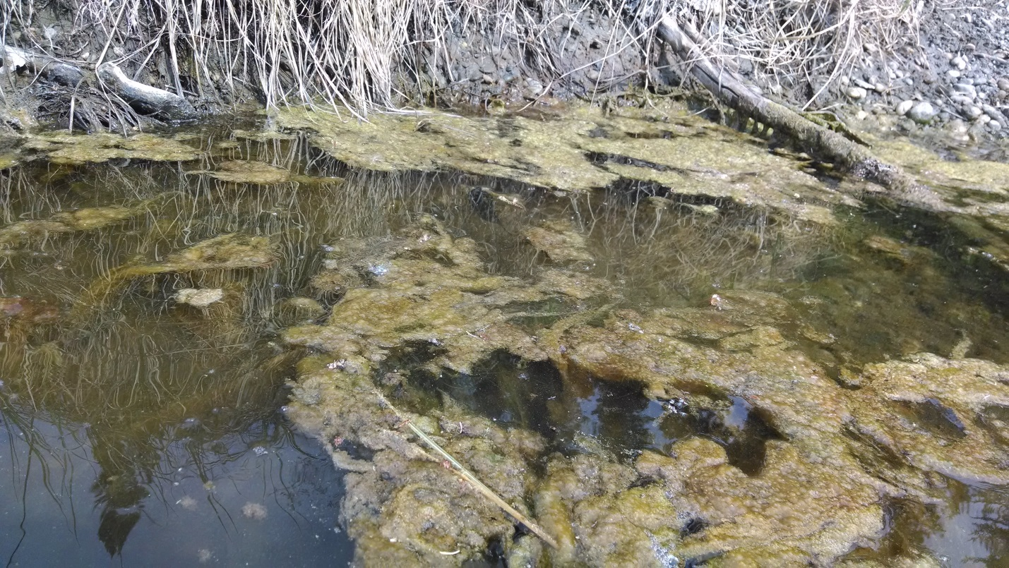Algae found on Lower Piledriver Slough just downriver of the Culverts on July 27 2014.
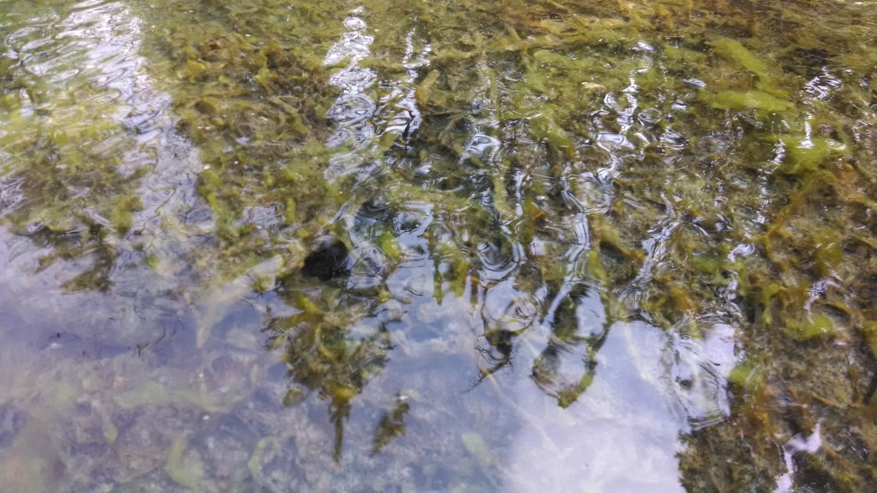
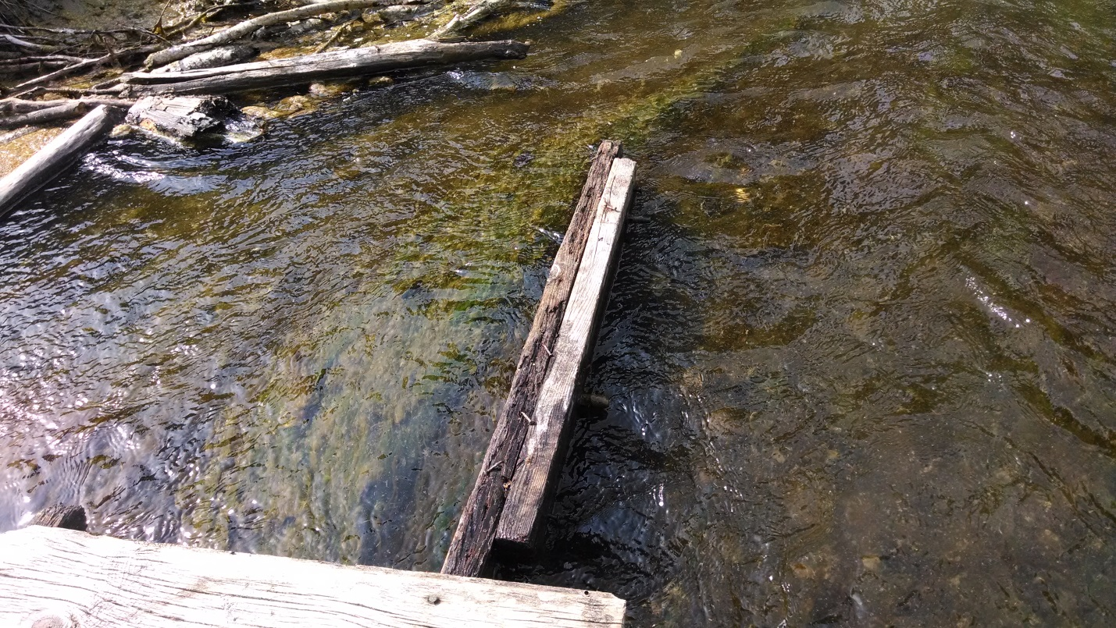
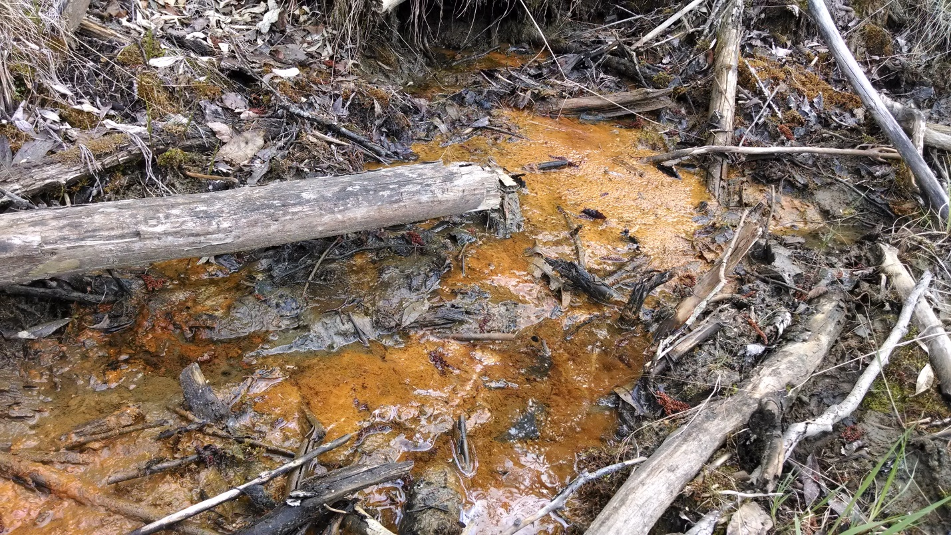
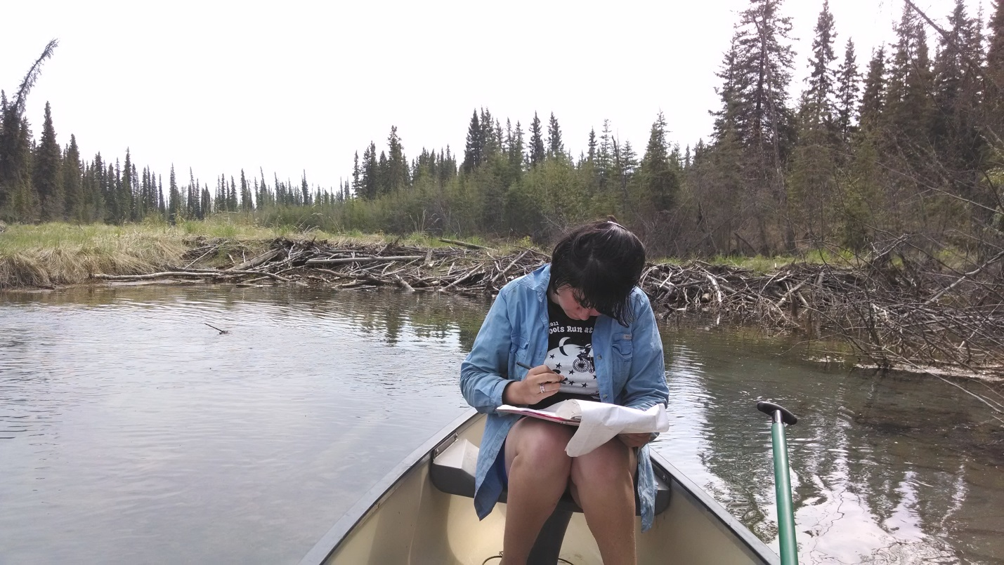TVWA volunteer Megan Bush records data on May 27 float of lower Piledriver
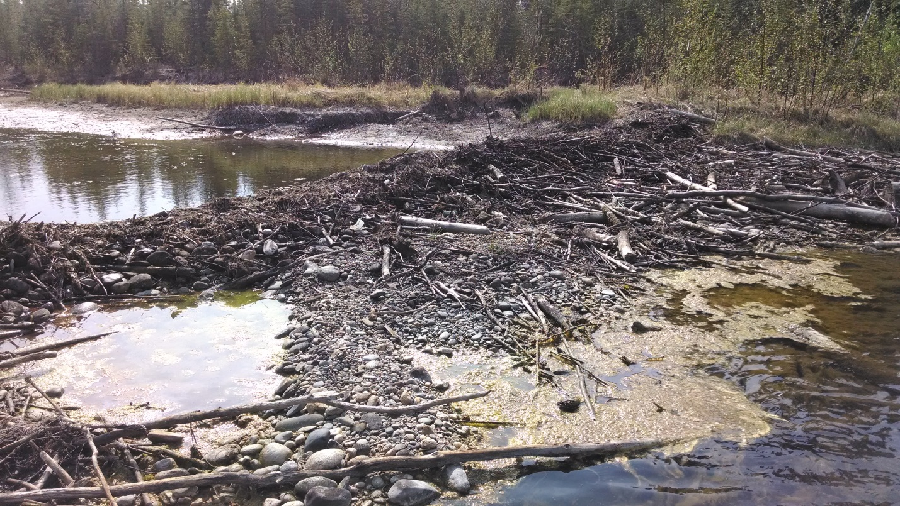
Old dam sites blocked passage in May due to unusually low water.
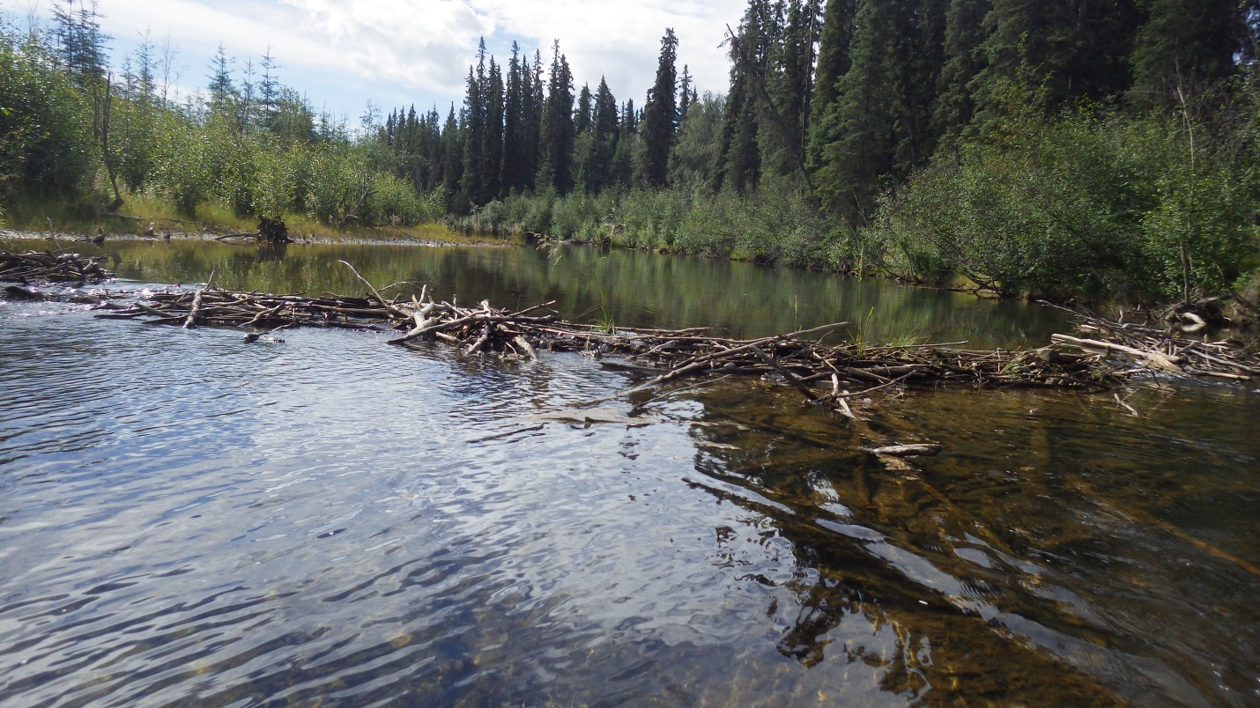
Old dam site blocks less passage in June as water levels rise.
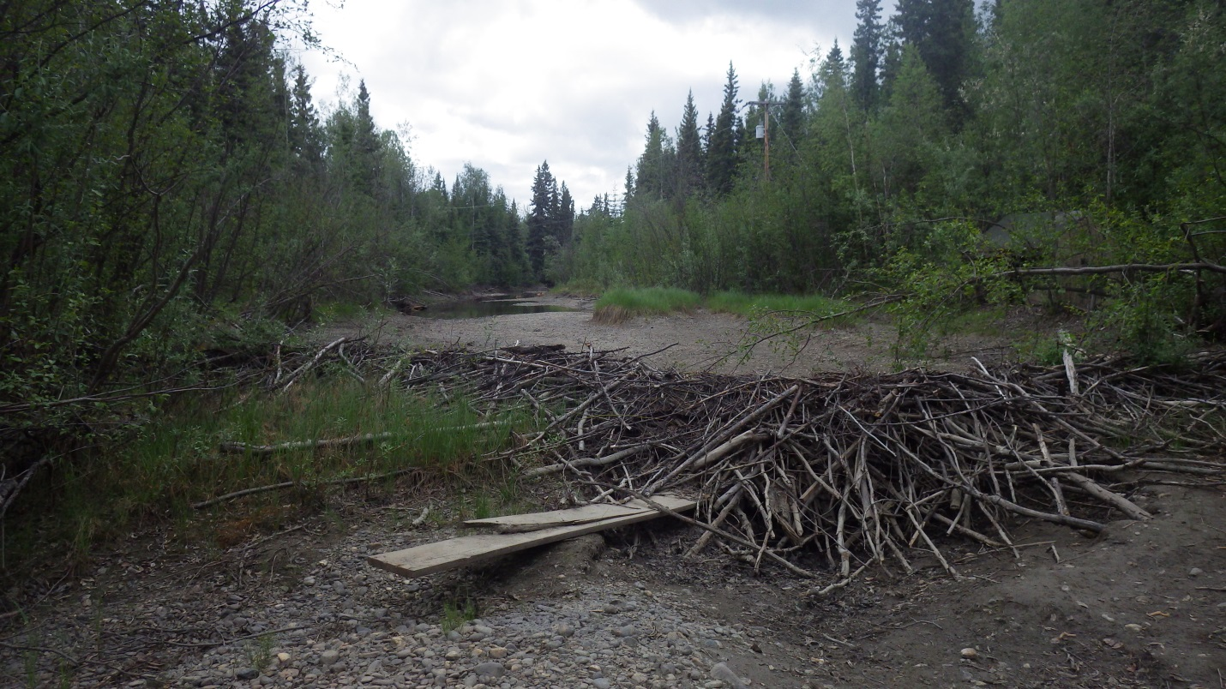
Old beaver dam site in “drought” of May.

