Juvenille Chena River Salmon Project 2014
Juvenile Chinook salmon (Oncorhynchus tshawytscha) in the Chena River corridor through Fairbanks, AK: Using citizen scientists to build community stewardship.

Project RM#: 32-15

Award F14AP00489

February 20, 2015

Times New Roman, 12 font, size 10 for tables and figures; single spacing except between paragraphs

Project Proponent: : Jewelz Barker, Tanana Valley Watershed Association, 516 2nd Avenue, Suite 412, Fairbanks AK 99701, tvwatershed@gmail.com
Project Partner: Jeff Adams, FFWFO, 101 12th Ave, Fairbanks AK 99701, jeff_adams@fws.gov

Introduction: The Chena River Salmon Project has used citizen scientists to study juvenile Chinook salmon in conjunction with an outreach campaign targeted at residents and visitors to increase their awareness of the importance of Chinook salmon in the Chena River. TVWA built support of the Chinook salmon population, by focusing on outreach and education efforts using social media and at major community events to build community knowledge about the Chena River Chinook salmon population.

Summary: The primary goal of this project was to increase the Fairbanks community’s stewardship of the Chena River Chinook salmon population; more specifically, to build the public’s awareness of out-migrating juveniles, juvenile salmon use of the Lower Chena River’s stream bank habitats, the characteristics of stream banks that are beneficial to juvenile survival, and the individual and collective actions that can be taken to conserve, restore, and promote healthy stream banks in the Lower Chena River.

Objectives: The objectives of the project were as follows:
- Engage the community; through information booths at 5 or more public events, conducting at least 4 on river project demonstrations, and coordinate current Chena Chinook information available on the internet.
- Build awareness of Chena River Chinook salmon; in addition to the success we encountered at the Outdoor Show and Chena River Summit, we will expand our awareness efforts to host a booth at the Alaska Fish and Game’s Kids Day as well as hosting a booth at the Summer Solstice downtown in an effort to reach many of the 30,000 attendees.
- Increase public participation in complementary efforts such as Green Infrastructure practices, stormwater management and design, riparian zone regulations and other stewardship programs. Which we will document though increased participating in the US Fish & Wildlife’s Partners program, Fairbanks’ Green Infrastructure Group projects and increased participation in TVWA’s Adopt a Stream Program.
- Incorporate awareness of Chena River Chinook salmon in local environmental education in schools and summer camps. Coordinating with the multiple agencies and resources available and creating a user friendly guide to help teachers, parents and educators access educational materials.

Study Area:
The study area is the Lower Chena River, with the geospatial location of 64.797527, -147.19288.

Figure 1: Sample locations along the Lower Chena River from Moose Creek Dam to the confluence at the Tanana River.

License and Permits: AKDFG Fish Resource Permit SF2014-105

Methods Include:
Our sampling took place between May 2014 and October 2014. Sampling procedures involve three areas, which are water quality, fish monitoring, and habitat assessment. Water quality used a Hanna meter to record water pH and conductivity and a thermometer to record ambient temperatures. This instrument was standardized before every reading and after to ensure accuracy, using standards of pH 4, pH 10, and 1413 conductivity solutions. The sampler collected a sample of water to use the Hanna meter to record the water’s pH, conductivity, and temperature onto a water quality datasheet. The sampler also documented weather, ambient temperature, and field observation, such as wildlife or erosion. Conductivity, pH, temperature and habitat conditions recorded provided insight to the overall water quality of the river area sampled. Datasheets were collected for database entry and analysis by TVWA staff.
The fish monitoring technique used included baited minnow traps that followed a protocol of a 24-hr soak period to capture fish and record quantity, species type, and other information on a datasheet. The minnow traps were 23 x 45 cm, 0.6 cm wire mesh, with 2.5 cm diameter openings holding salmon roe bait in order to maximize the probability of encountering as many fish species in different life stages as possible. A fish viewer and mesh net was also used in conjunction with a bucket in order to access the fish from the minnow trap, observe, and record the information. The fish, once recorded quantitative parameters (e.g. quantity per species, Chinook length, dead fish) was completed, were released back into the river. Fish handling required the fish to be in the river water at the sampling site location and with minimal contact with the fish. The datasheet were collected for database entry and analysis by TVWA staff.
The final monitoring will include habitat assessment done at the beginning of sampling season, mid-season, and at the end of the season to gather information throughout the monitoring project. The datasheet captured the habitat, river, and streambank conditions, which were collected for database entry and analysis by TVWA staff. All datasheets from habitat, fish, and water quality were used in reporting and graphical depiction of the results from the Chena Salmon Citizen Science program.

Operations:
We held outreach events at:
- 4.13.14 Spring Migration/Outdoor Kids Day @ Creamers Field
- 4.25-4.27 Outdoor Days @ the Carlson Center
- 5.7.14 Chena River Summit @ the Carlson Center
- 5.10.14 AAS Training
- 5.17.14 AKDF&G Kids Day @ Creamers Field
- 6.14.14 Riverwalk Event @ Carlson Center
- 6.22.14 Solstice Street Fair @ Downtown Fairbanks
- 7.12.14 AAS Training – Moose Creek
- 7.20.14 Golden Days @ Pioneer Park
- 7.27-8.2 Week on the River – the Folk School
- 8.8.14 Tanana Bridge Crossing Dedication
- 8.17.14 Renewable Energy Fair @ Chena Hot Springs
- 10.3.14 Rain 2 Rivers Resource Center Open House

Data Analysis:
We handed out the following materials:
- 600+ of the Alaska Fish ABC’s coloring books
- 550+ of the Chena River Salmon project branded coloring crayons
- 300+ USF&W Salmon of the Pacific Coast pamphlets
- 300+ Chena Salmon Citizen Scientists Handout

Results Include (Minimum):
TVWA continued to talk to thousands of people throughout 2014. We provided a wide range of information on everything salmon related and Chena River related. We had highlighted central aspects of salmon and Chena related topics, which include:
- Salmon life cycle as it pertains to the Chena river
- Healthy habitat information
- Types of fish that live in the Chena river
- Value of the Chena to the Chinook salmon
- How many fish we caught and where
- Reasons as to why the numbers vary from year to year
- Some of the changes we saw over the course of the project
- The methods we used in catching them and why

We also created a handout with all of the collected information over the past 3 years (Appendix A). This year, for 2014 we had collaboratively recorded the 24 collected fish, which average lengths were between 53 and 55 mm (Table 1). Our highest fish species count was the slimy sculpin (14) with chum salmon following (9) (Figure 2).

Table 1: Lengths (average) of the salmon caught for 2014 per species in millimeters (mm).
Species | Average Length (mm)
Chinook Salmon | 55.00
Chum Salmon | 53.78

Figure 2: Number of fish caught per species in 2014.

Discussion:
The open water season for 2014 was faced with high water. Given abnormally high water during the setting season, our results are very low because of unfavorable conditions for setting traps and checking.

References:
N/A

Appendices:
Appendix A: CSCS Handout Sample
Appendix B: Data of Fish Samples 2014

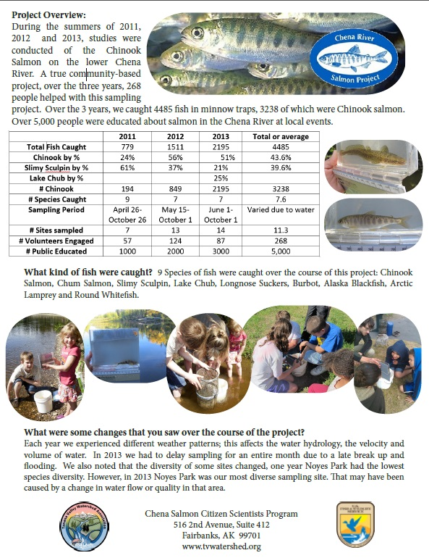
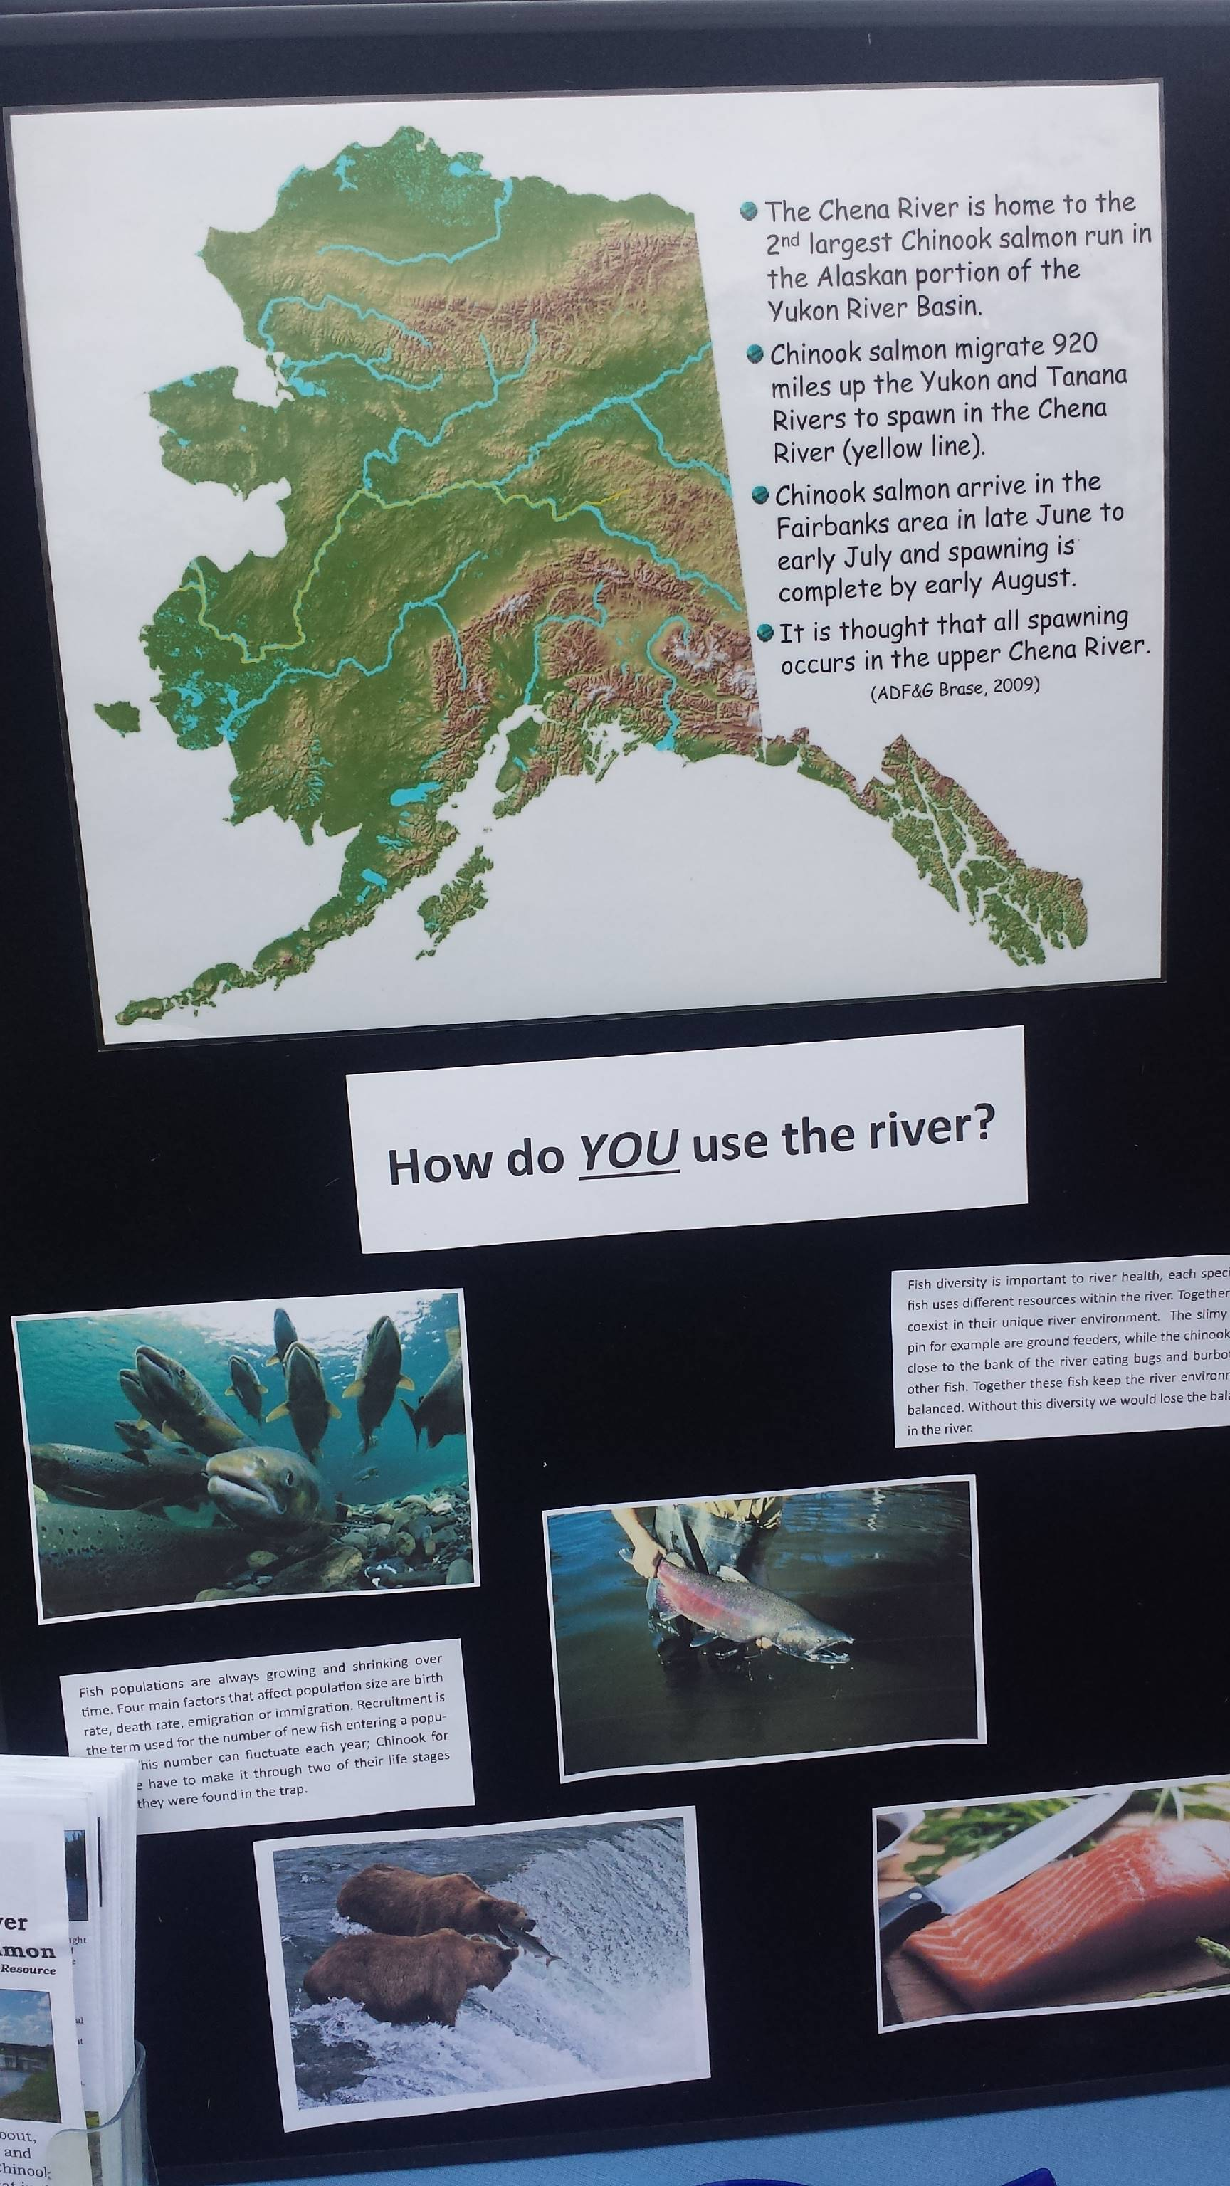
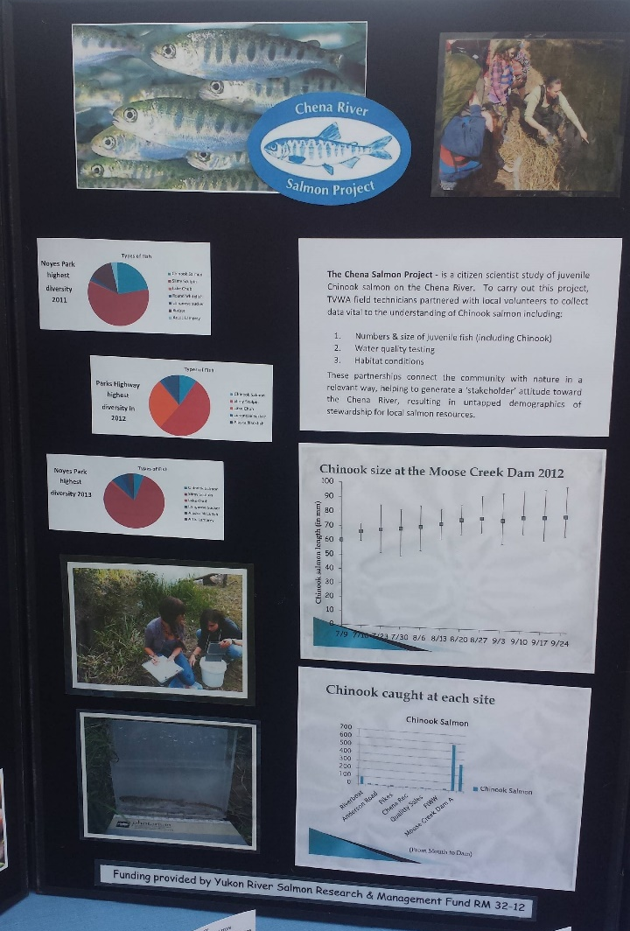
Appendix A: CSCS Handout Sample

Appendix B: Data of Fish Samples 2014

Date | Observer name (first name, middle initial, last name) | Fish collection method | Species | Life stage | Length (mm)  No estimates/ranges | Length method
7/12/14 | Jenna E Hertz | Minnow Trap | Chinook salmon | juvenile | 55 | fork
7/12/14 | Jenna E Hertz | Minnow Trap | Chum Salmon | juvenile | 55 | fork
7/12/14 | Jenna E Hertz | Minnow Trap | Chum Salmon | juvenile | 60 | fork
7/12/14 | Jenna E Hertz | Minnow Trap | Chum Salmon | juvenile | 50 | fork
7/12/14 | Jenna E Hertz | Minnow Trap | Chum Salmon | juvenile | 52 | fork
7/12/14 | Jenna E Hertz | Minnow Trap | Chum Salmon | juvenile | 50 | fork
7/12/14 | Jenna E Hertz | Minnow Trap | Chum Salmon | juvenile | 50 | fork
7/12/14 | Jenna E Hertz | Minnow Trap | Chum Salmon | juvenile | 60 | fork
7/12/14 | Jenna E Hertz | Minnow Trap | Chum Salmon | juvenile | 57 | fork
7/12/14 | Jenna E Hertz | Minnow Trap | Chum Salmon | juvenile | 50 | fork
7/12/14 | Jenna E Hertz | Minnow Trap | Slimy Sculpin | juvenile
7/12/14 | Jenna E Hertz | Minnow Trap | Slimy Sculpin | juvenile
7/12/14 | Jenna E Hertz | Minnow Trap | Slimy Sculpin | juvenile
7/12/14 | Jenna E Hertz | Minnow Trap | Slimy Sculpin | juvenile
7/12/14 | Jenna E Hertz | Minnow Trap | Slimy Sculpin | juvenile
 |  |  | Slimy Sculpin | juvenile
7/12/14 | Jenna E Hertz | Minnow Trap | Slimy Sculpin | juvenile
7/12/14 | Jenna E Hertz | Minnow Trap | Slimy Sculpin | juvenile
7/12/14 | Jenna E Hertz | Minnow Trap | Slimy Sculpin | juvenile
7/12/14 | Jenna E Hertz | Minnow Trap | Slimy Sculpin | juvenile
7/12/14 | Jenna E Hertz | Minnow Trap | Slimy Sculpin | juvenile
7/12/14 | Jenna E Hertz | Minnow Trap | Slimy Sculpin | juvenile
7/12/14 | Jenna E Hertz | Minnow Trap | Slimy Sculpin | juvenile
7/12/14 | Jenna E Hertz | Minnow Trap | Slimy Sculpin | juvenile

